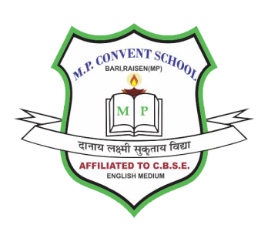
M.P CONVENT SCHOOL BARI
(AFFILIATED TO C.B.S.E. NEW DELHI UPTO SR.SECONDARY)
SHAKTI NAGAR WARD NO.6 BADI RAISEN (M. P.)-464665

RESULT OF LAST THREE YEAR CLASS XII
Year | Appeared | Pass | Percentage
2022-23 | 32 | 24 | 75
2023-24 | 09 | 06 | 66.67
2024-25 | 10 | 07 | 70

RESULT OF LAST THREE YEAR CLASS X
Year | Appeared | Pass | Percentage
2022-23 | 74 | 65 | 87.84
2023-24 | 58 | 53 | 91.38
2024-25 | 60 | 58 | 96.67

